Green’s Function ODE Solver

Project 3 – Green’s Function and ODE with IVP
CST-305: Principles of Modeling and Simulation Design
Jordan Cruze
Dr. Citro
10/18/2026

GitHub Link: https://github.com/Jordan-Cruze/CST-305
- Team Responsibilities
Team Member | Responsibilities
Jordan Cruze | Mathematical derivation, Python implementation, testing, documentation

- Problem Description
The purpose of this project is to develop a Python program capable of solving second-order linear ordinary differential equations using Green's functions. The program accepts a differential equation as text, determines the corresponding coefficients and forcing function, constructs the appropriate Green's function, evaluates the resulting integral, and verifies the solution.
The program is designed for linear constant-coefficient initial value problems of the form
$$ay^{''}+by^{'}+cy=f(t)$$
with zero initial conditions
$$y\left(0\right)=y^{'}\left(0\right)=0$$

For zero initial conditions, the Green’s-function solution is:
$$y\left(t\right)=\int_{0}^{t}{G\left(t,τ\right)f\left(τ\right)}dτ$$
where $G(t, τ)$ is the Green’s function associated with the homogeneous differential equation.
The problem also solves the homogeneous equation symbolically, verifies the resulting solution by substituting it back into the original differential equation, and compares the symbolic Green’s-function solution with a numerical solution generated using SciPy.
The program was tested using the two assigned differential equations:
$$y^{''}+y=4$$
$$y^{''}+4y=t$$
The results from the program agree with the analytical solutions obtained using Green’s functions.
- Mathematical Approach
  - Homogeneous Equation
For a differential equation
$$ay^{''}+by^{'}+cy=f(t)$$
the associated homogeneous equation is
$$ay^{''}+by+cy=0$$
The homogeneous equation is solved first to determine the functions needed to construct the Green’s function.
For a second-order equation, theGreen’s function is constructed so that it satisfies the homogeneous equation away from $t=τ$, while satisfying the conditions
$$G\left(τ,τ\right)=0$$
and
$$G_{t}\left(τ, τ\right)=\frac{1}{a}$$
For the zero initial conditions used in this project, the solution is then calculated using
$$y\left(t\right)=\int_{0}^{t}{G\left(t, τ\right)}f(τ)dτ$$

  - Assigned Problem 1
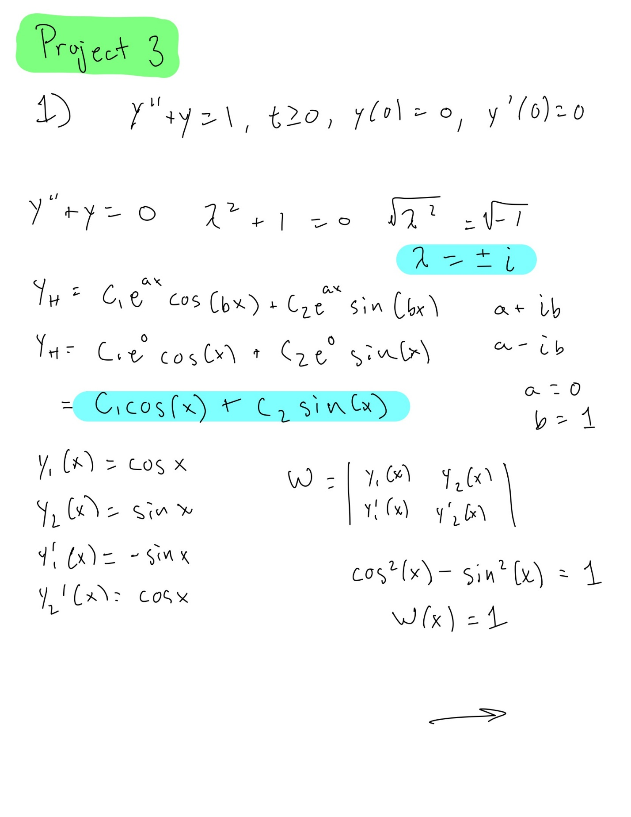
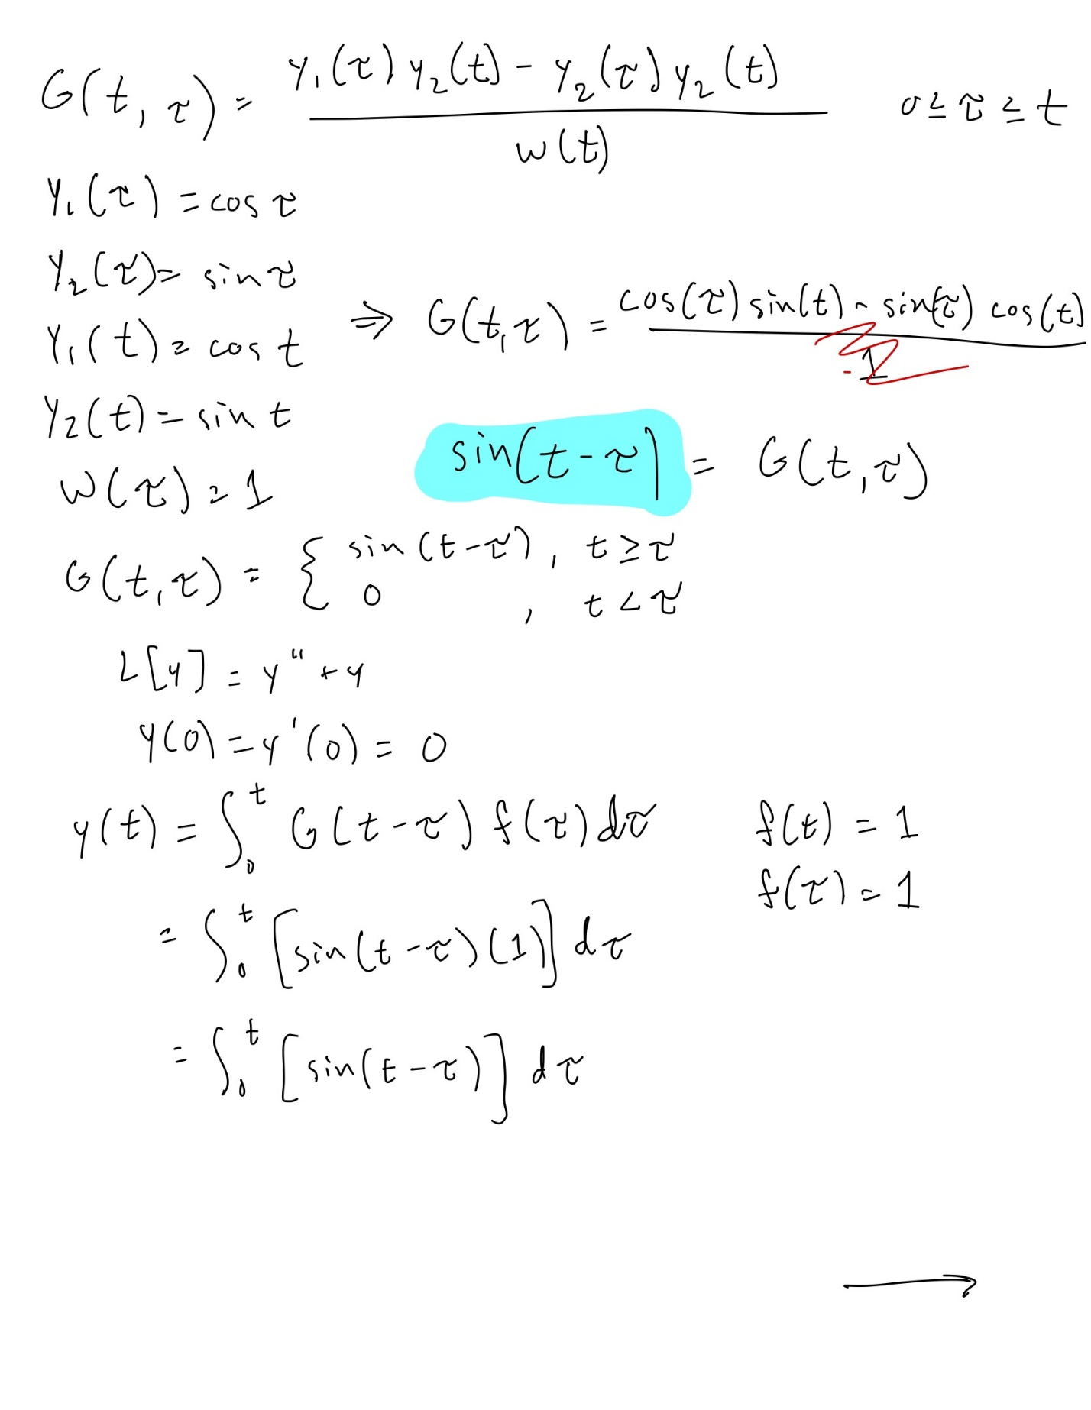

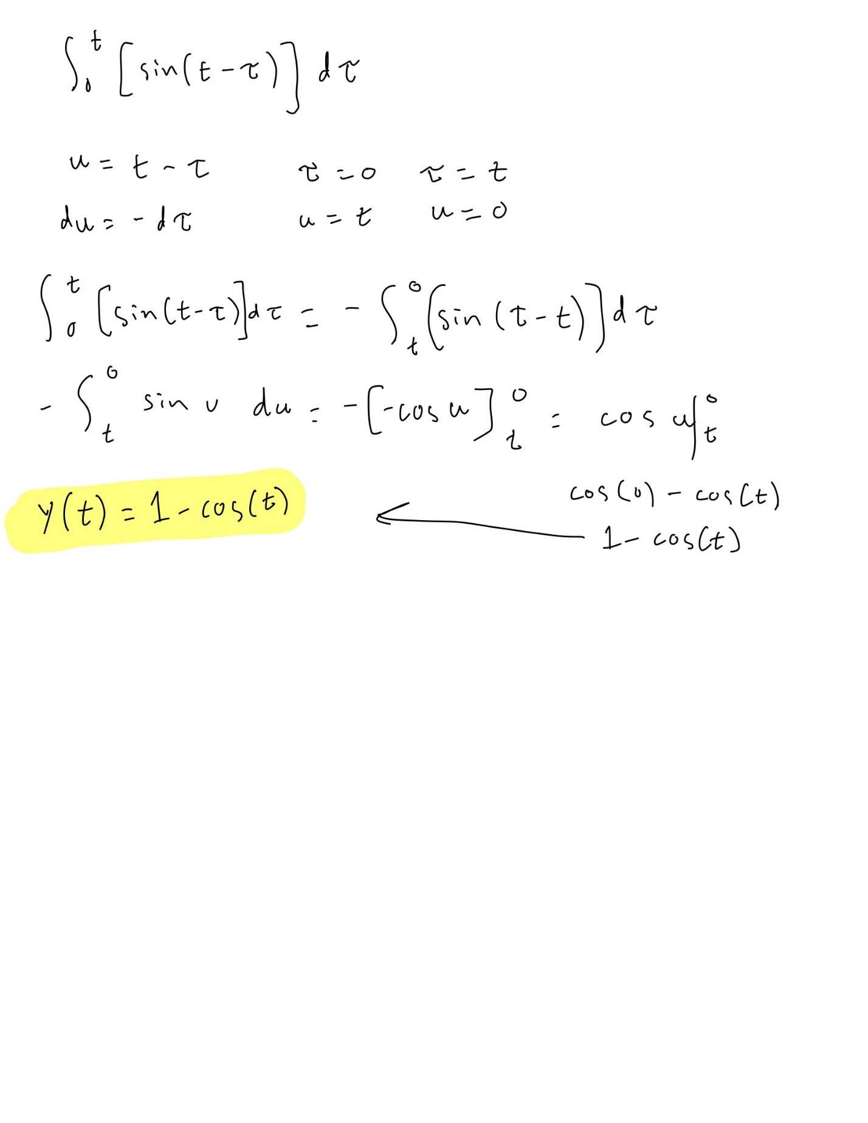

  - Assigned Problem 2
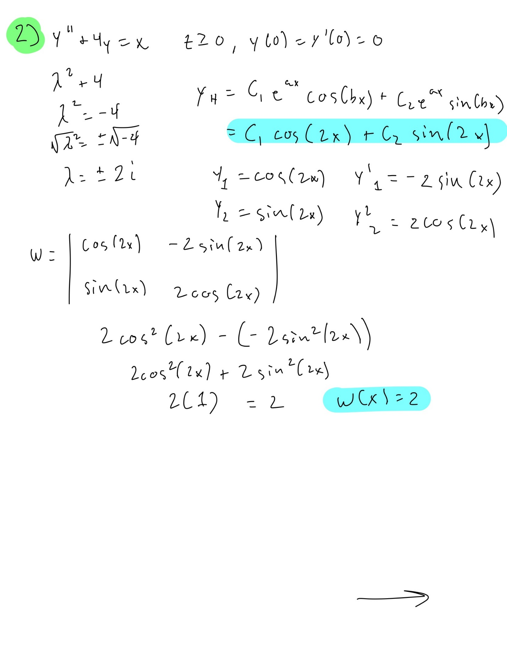
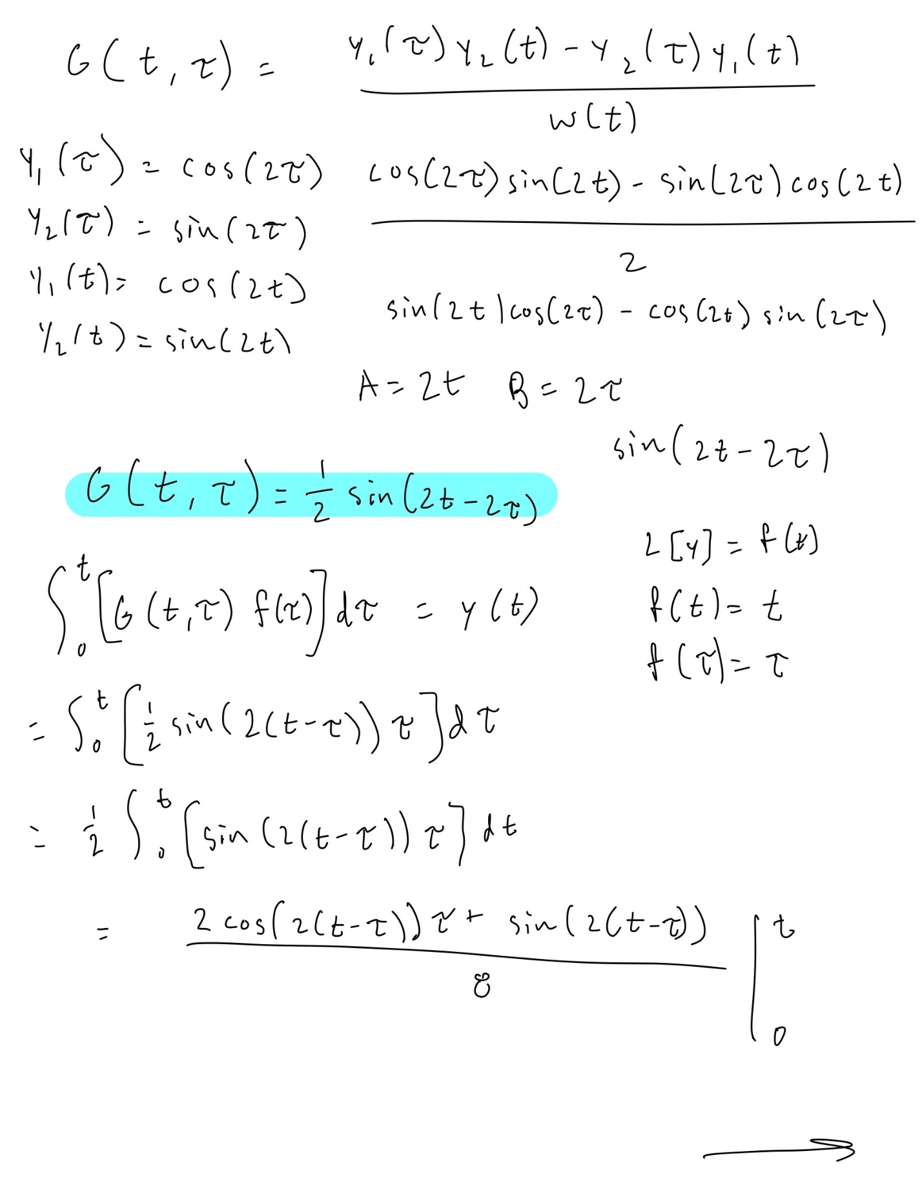

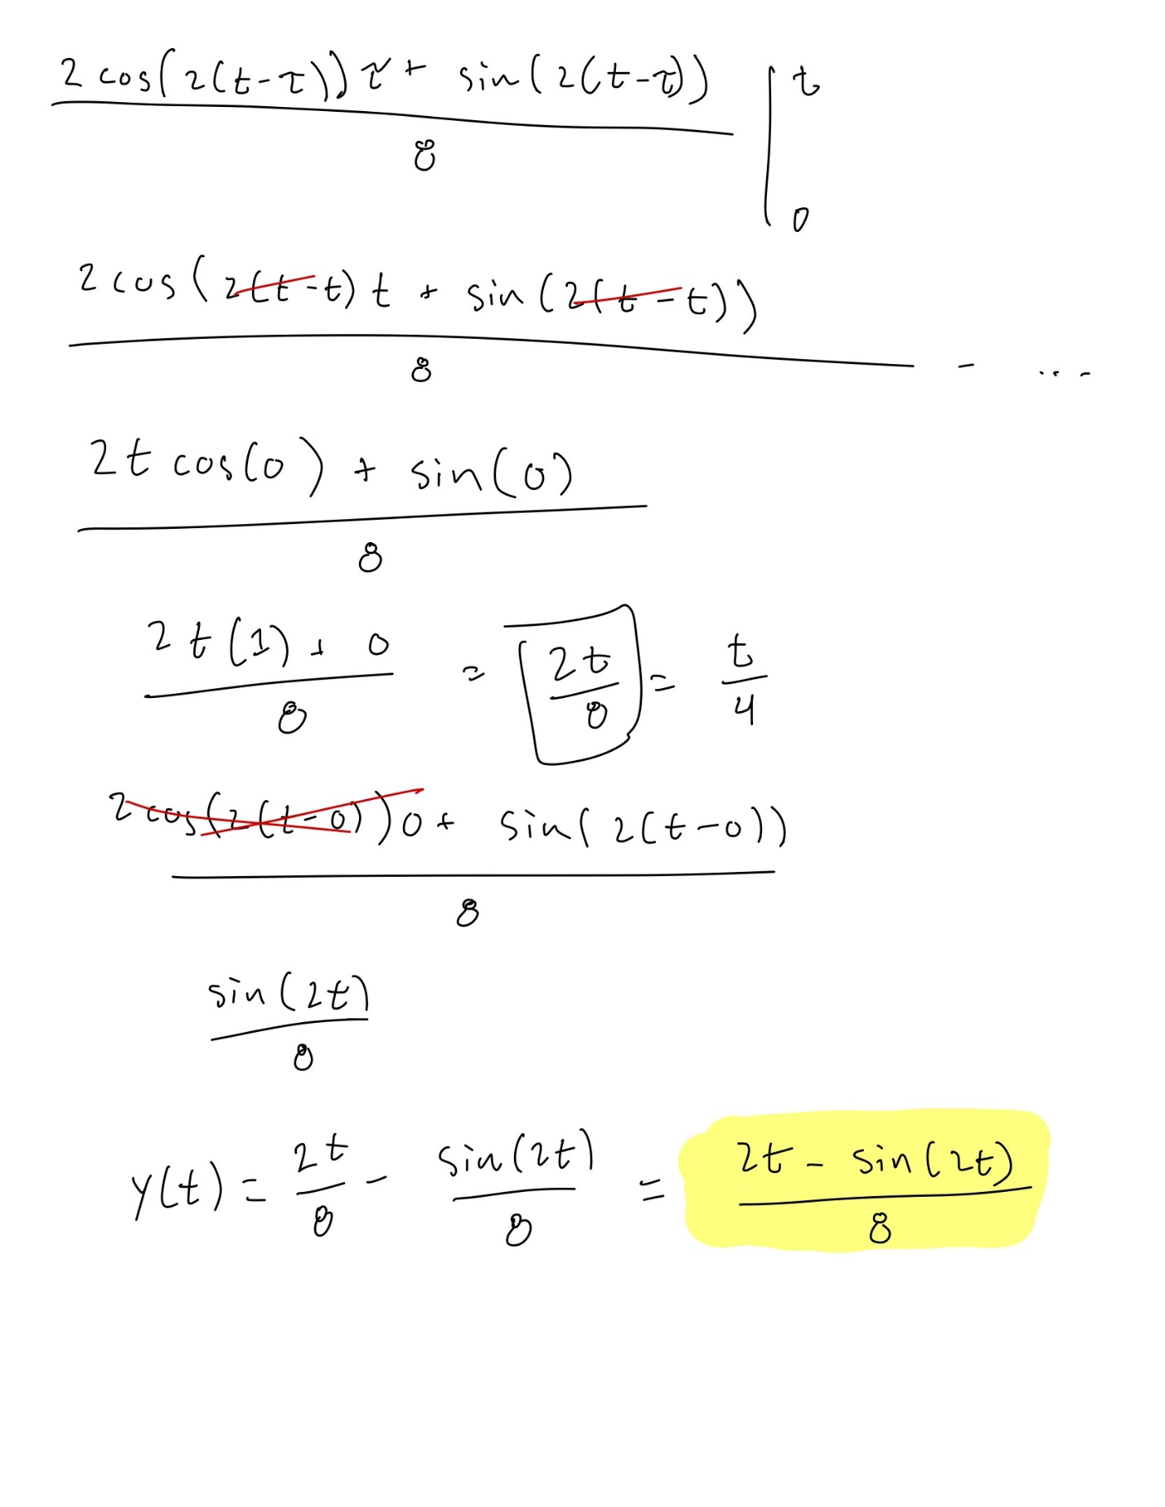

- Python Implementation
The program was implemented in Python using NumPy, SciPy, and Matplotlib.
The major packages used are:
- SymPy — symbolic equation parsing, differential equation solving, Green's-function construction, integration, and verification.
- NumPy — numerical arrays and sampling of the time interval.
- SciPy — numerical solution of the initial value problem using solve_ivp.
- Matplotlib — generation of static plots and animation.
The source code is contained in main.py.
  - Input Parsing
The parse_ode() function accepts equations written as text. For example:
y''+y=4
or
y ' '+4*y=x
The parser converts the equation into the standard form
$$ay^{''}+by^{'}+cy=f(t)$$
For the two assigned problems, the resulting coefficients are:
ODE | a | b | c | f(t)
$$y^{''}+y=4$$ | 1 | 0 | 1 | 4
$$y^{''}+4y=t$$ | 1 | 0 | 1 | t

The program accepts either $t$ or $x$ as the independent variable.

  - Homogeneous Solution
The homogeneous_solution() function creates the homogeneous differential equation
$$ay^{''}+by^{'}+cy=0$$
and uses SymPy's dsolve() function to determine its general solution.

For example, the second assigned equation produces
$$C_{1}\sin\left(2t\right)+C_{2}cos⁡(2t)$$
This is equivalent to the manually derived form
$$C_{1}\sin\left(2t\right)+C_{2}cos⁡(2t)$$
because the arbitrary constants can be renamed.

  - Green’s Function
The greens_function() function obtains a symbolic solution to the homogeneous equation and determines the constants required to satisfy
$$G\left(τ, τ\right)=0$$
and
$$G_{t}\left(τ, τ\right)= \frac{1}{a}$$

For the two assigned problems, the program produces:
$$G_{1}\left(t, τ\right)=sin⁡(t-τ)$$
and
$$G_{2}\left(t, τ\right)= \frac{1}{2}sin⁡(2t-2τ)$$

  - Green’s Function Integration
The particular_and_total() function substitutes the forcing function into
$$y\left(t\right)=\int_{0}^{t}{G\left(t,τ\right)f\left(τ\right)dτ }$$
SymPy evaluates the integral symbolically and simplifies the result.

The resulting solutions are:
$$y_{1}\left(t\right)=4-4cos⁡(t)$$
and
$$y_{2}\left(t\right)=\frac{2t-sin⁡(2t)}{8}$$
  - Symbolic Verification
The check() function verifies the calculated solution by evaluating the residual
$$ay^{''}+by^{'}+cy-f(t)$$
A correct solution should produce a residual of zero.

The program also evaluates
$$y(0)$$
and
$$y'(0)$$
to verify the initial conditions.

For both assigned equations, the program reported:

Verification: ODE residual = 0 -> True
$$y\left(0\right)=0$$
$$y'\left(0\right)=0$$
This confirms that the symbolic Green's-function solutions satisfy both the differential equations and the specified initial conditions.
- Numerical Verification
In addition to symbolic verification, the program compares the Green's-function solution with a numerical solution of the same initial value problem.
The numerical solution is generated using SciPy's solve_ivp() function. The numerical solution and symbolic solution are evaluated at the same time points, and the maximum absolute difference is calculated.

For the first assigned equation,
$$y^{''}+y=4$$
the Green’s-function solution is
$$y\left(t\right)=4-4cos⁡(t)$$
The maximum absolute difference between the Green’s function solution and the numerical solution was approximately
$9.15* {10}^{-9}$ m
For the second assigned equation,
$$y^{''}+4y=t$$
the Green’s-function solution is
$$y\left(t\right)=\frac{2t-sin⁡(2t)}{8}$$
The maximum difference was approximately
$1.83* {10}^{-9}$ m
These errors are extremely small, indicating that the numerical solutions closely agree with the symbolic Green’s-function solutions. This provides numerical confirmation that the implemented Green’s-function method produces the expected results.
Equation | Green’s Function Solution | Maximum Difference
$$y^{''}+y=4$$ | $$y\left(t\right)=4-4cos⁡(t)$$ | $9.15* {10}^{-9}$ m
$$y^{''}+4y=t$$ | $$y\left(t\right)=\frac{2t-sin⁡(2t)}{8}$$ | $1.83* {10}^{-9}$ m

- Graphical Output
The program generates multiple forms of graphical output.
  - Homogenous Solution Plots
The first figure displays the basis solutions of the homogeneous differential equation and the homogeneous component of the final IVP solution.
This allows the homogeneous behavior of the system to be examined independently from the forced response.
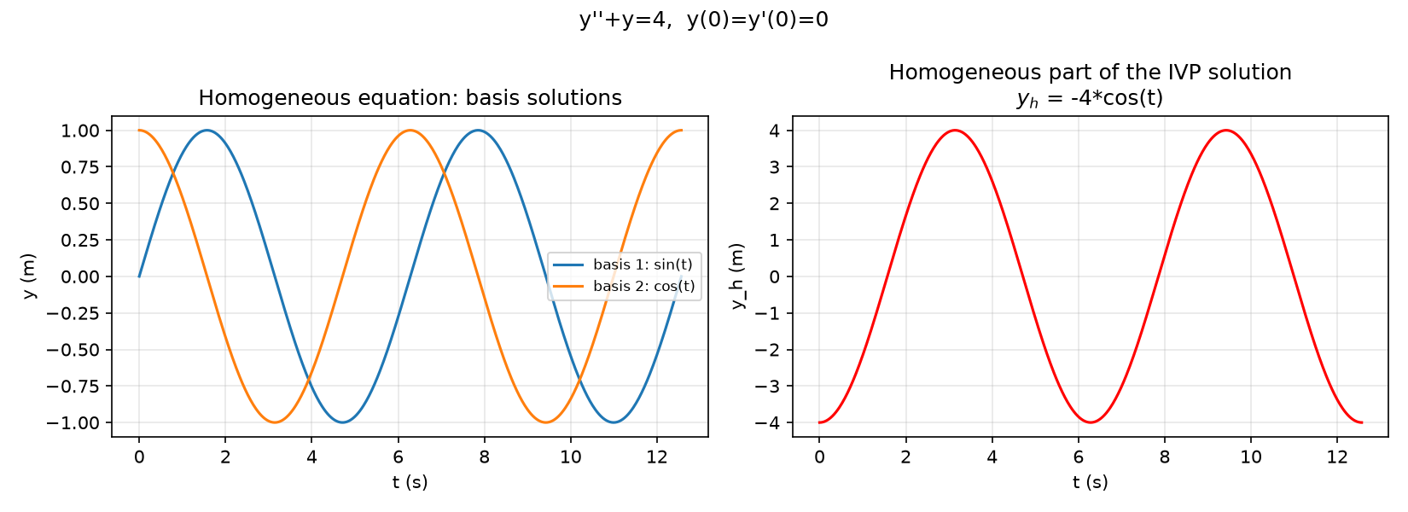
Figure 1. Homogeneous basis solutions and homogeneous component of the IVP solution generated by the Python program for the first equation.
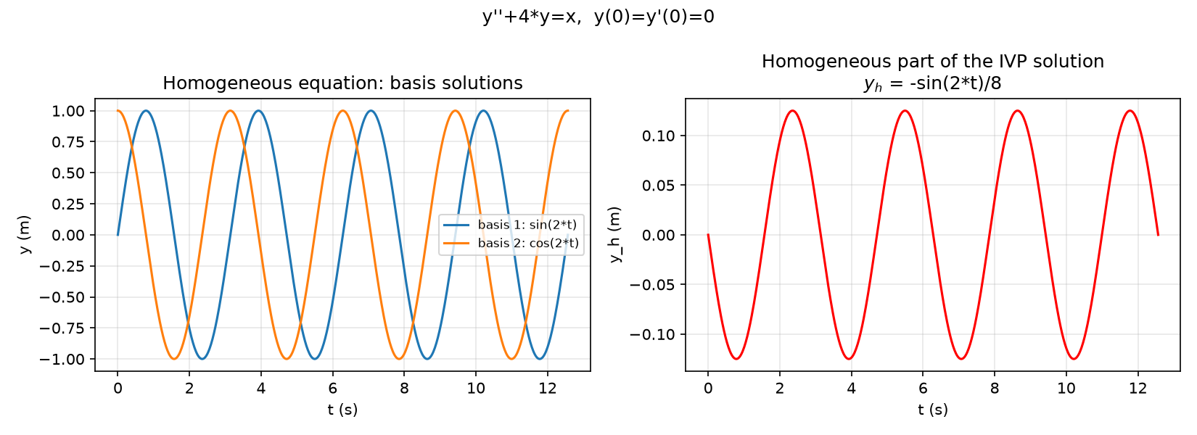
Figure 2. Homogeneous basis solutions and homogeneous component of the IVP solution generated by the Python program for the second equation.

  - Green’s Function Solutions
The second figure compares four quantities:
- the complete Green's-function solution,
- the particular solution,
- the homogeneous component,
- the numerical solution.
For the first assigned equation, the complete solution is
$$y\left(t\right)=1-cos⁡(t)$$
For the second assigned equation, the complete solution is
$$y\left(t\right)=\frac{2t-sin⁡(2t)}{8}$$
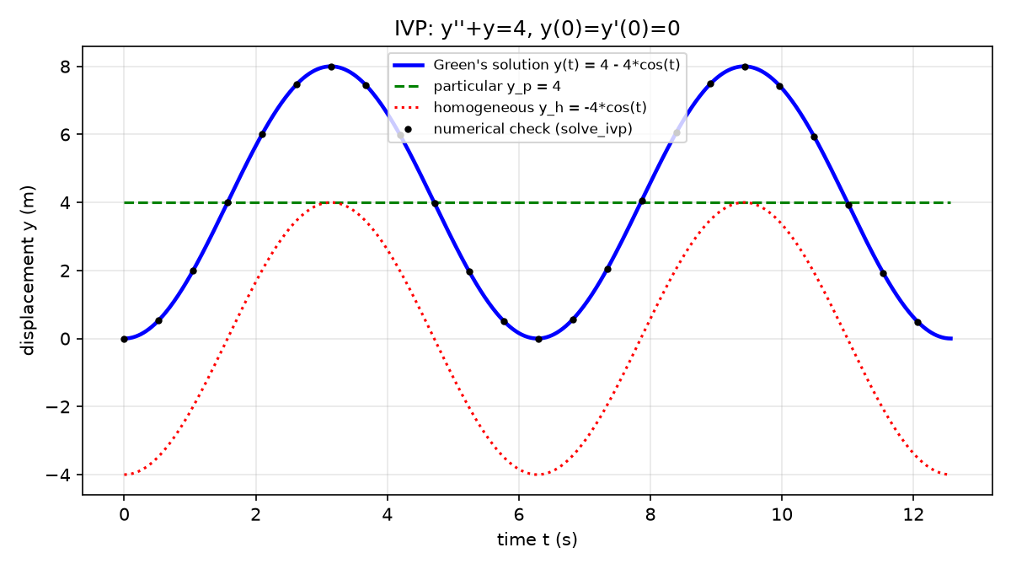
Figure 3. Comparison of the Green's-function solution, particular solution, homogeneous component, and numerical solution for the first equation.
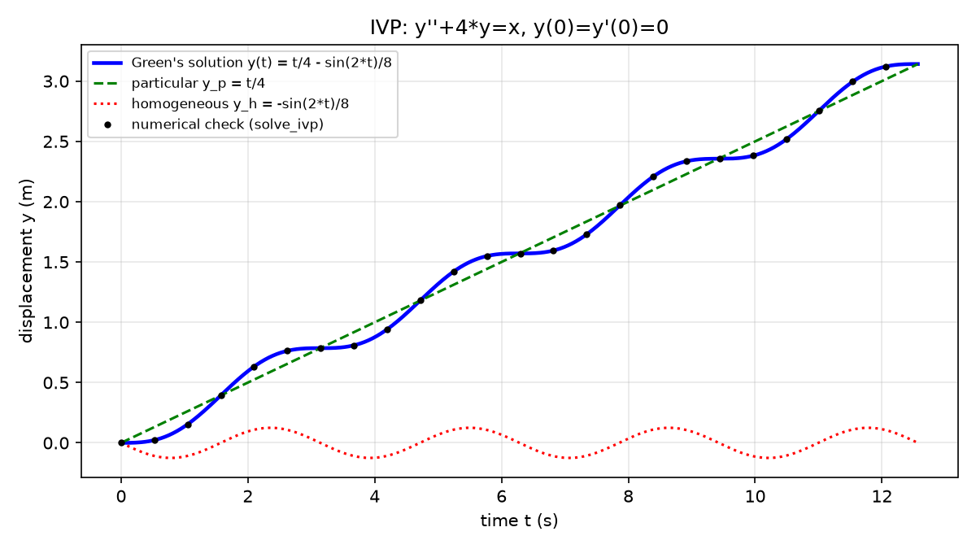
Figure 4. Comparison of the Green's-function solution, particular solution, homogeneous component, and numerical solution for the second equation.
  - Green’s Function Animations
The program also produces an animation showing how the Green's-function integral builds the solution.
The animation displays the integrand
$$G\left(t, τ\right)f(τ)$$
as (\tau) progresses from (0) to (t). The accumulated area under the integrand corresponds to the value of
$$y\left(t\right)=\int_{0}^{t}{G\left(t, τ\right)f\left(τ\right) dτ}$$
This provides a visual representation of how the forcing function contributes to the final solution.
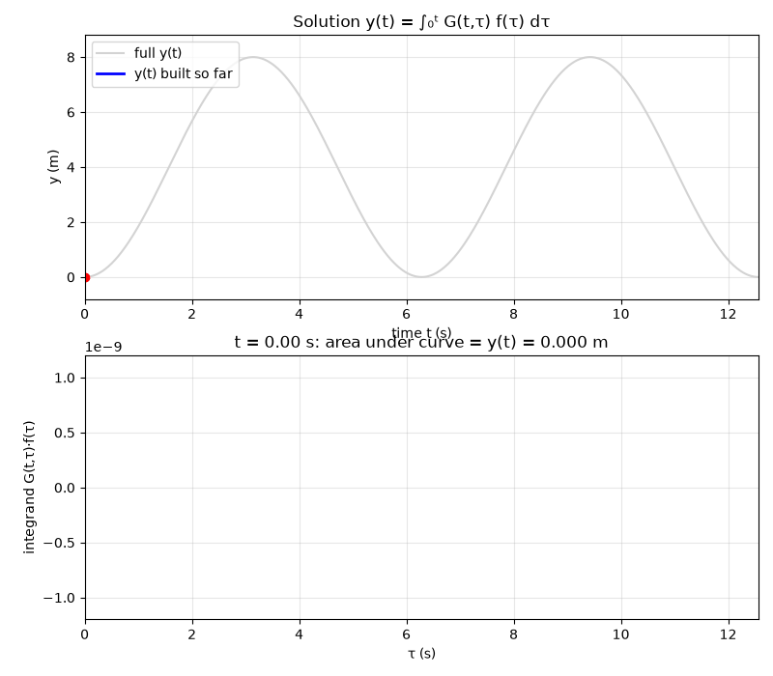
Figure 5. Green's-function integral visualization showing the accumulation of the forced response for the first equation.
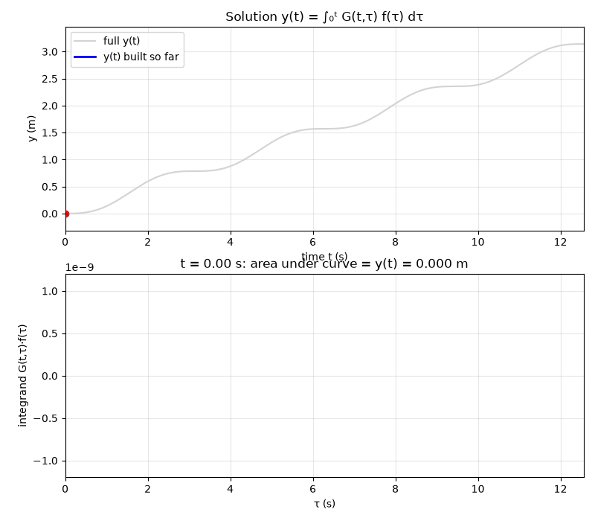
Figure 6. Green's-function integral visualization showing the accumulation of the forced response for the second equation.

- Algorithm and Program Flow
The overall operation of the program follows these steps:
- Start the program.
- Read the differential equation from the user.
- Parse the equation into (a), (b), (c), and (f(t)).
- Construct the corresponding homogeneous equation.
- Solve the homogeneous equation symbolically.
- Construct the Green's function using the required initial conditions.
- Evaluate the Green's function integral.
- Simplify the resulting solution.
- Verify the differential equation and initial conditions.
- Numerically solve the initial value problem.
- Compare the numerical and symbolic solutions.
- Generate the homogeneous solution graph.
- Generate the Green's function solution graph.
- Generate the Green's function animation.
- Display the results.

Flowchart
Figure 7. Program flowchart showing the process from ODE input through symbolic solution, verification, numerical comparison, and graphical output.

- System and Program Environment
The program was developed and tested using the following environment:
Component | Configuration
Operating System | Windows 11
Processor | Intel Core i9-14900HX
RAM | 32GB
Python Version | Python 3.14.7
SymPy | 1.14.0
NumPy | 2.5.3
SciPy | 1.18.1
Matplotlib | 3.11.2

The program uses symbolic computation to derive the Green's-function solution and numerical computation to verify the result. Increasing the number of evaluation points or decreasing the numerical solver tolerances can increase computational work while potentially improving numerical accuracy.

- Results and Discussion
The program successfully solved both assigned differential equations using Green's functions.

For the first equation,
$$y^{''}+y=4$$
the program obtained
$$y\left(t\right)=4-4cos⁡(t)$$

For the second equation,
$$y^{''}+4y=t$$
the program obtained
$$y\left(t\right)=\frac{2t-sin⁡(2t)}{8}$$

Both results agree with the manually derived Green’s function solutions.
The symbolic verification produced zero residuals for both equations, confirming that the calculated functions satisfy their respective differential equations. The initial conditions were also correctly satisfied.
The numerical comparison produced errors on the order of ${10}^{-9}$, indicating very close agreement between the symbolic and numerical solutions.
The graphical output provides an additional method of verifying the results. In particular, the numerical solution overlaps the Green's function solution, while the separate homogeneous and particular components demonstrate how the final response is constructed.
The animation further illustrates the physical and mathematical interpretation of a Green's function. Rather than treating the forcing function as producing the entire response at once, the integral can be viewed as accumulating the response produced by the forcing over the interval from (0) to (t).
- Limitations
The current implementation is designed primarily for second-order linear differential equations with constant coefficients and zero initial conditions.
The program also depends on SymPy being able to symbolically solve the homogeneous equation and evaluate the Green's-function integral. Some equations may therefore require additional handling if SymPy cannot obtain a symbolic solution.
The current implementation uses SciPy's solve_ivp() for numerical verification. The numerical method and performance measurements should be interpreted according to the solver configuration used by the program.

- Conclusion
This project demonstrated the use of Green's functions to solve second-order linear initial value problems computationally. The Python program successfully parsed differential equations, determined their homogeneous solutions, constructed the corresponding Green's functions, evaluated the required integrals, and verified the resulting solutions.
For both assigned differential equations, the program produced the same analytical results obtained through manual calculation. The symbolic verification returned zero residuals and confirmed that the initial conditions were satisfied. Numerical comparison also produced errors on the order of (10^{-9}), demonstrating strong agreement between the analytical and numerical solutions.
The generated plots and animation provide additional visual verification and demonstrate how the Green's-function integral builds the forced response of the system.
Overall, the project demonstrates how symbolic mathematics, numerical methods, and graphical visualization can be combined in Python to analyze and verify solutions to differential equations.

References
Matplotlib Development Team. “matplotlib.animation.” Matplotlib Documentation, 2026. https://matplotlib.org/stable/api/animation_api.html
NumPy Developers. “NumPy Documentation.” NumPy, 2026. https://numpy.org/doc/
SciPy Developers. “Integration and ODEs.” SciPy Documentation, 2026. https://docs.scipy.org/doc/scipy/reference/integrate.html
SciPy Developers. “solve_ivp.” SciPy Documentation, 2026. https://docs.scipy.org/doc/scipy/reference/generated/scipy.integrate.solve_ivp.html
SymPy Development Team. “Integrals.” SymPy Documentation, 2026. https://docs.sympy.org/latest/tutorial/calculus.html?highlight=integrate
SymPy Development Team. “Solve an Ordinary Differential Equation (ODE) Algebraically.” SymPy Documentation, 2026. https://docs.sympy.org/latest/guides/solving/solve-ode.html
SymPy Development Team. “SymPy Documentation.” SymPy, 2026. https://docs.sympy.org/

